Peter Weibel
Archives as Models of Nature and Art
Übersetzung Steven Lindbergh, Publikation ARCHIVES VIVANTES, DCV Verlag Berlin, 2022

Archives are usually not visible or accessible to the public and are primarily committed to their specific collecting task. Many archives once held living plants, animals, and natural materials as “dead” objects assigned a number, inventoried according to special ordering systems, preserved overwhelmingly in the service of science and research. In order for objects in the collection to be visualized, experienced, and understood anew historically and in the future in their complex connections to nature, human beings, society and its values and framing and power conditions, new levels and systems are necessary now and again to enable new approaches to viewing. In that process art can make visible in a special and autonomous way what the archive is not showing: hidden parameters and patterns.
Sinje Dillenkofer’s concern is to translate into art both the “nature” of the artifacts, specimens, and graphic works of Alexander von Humboldt and Carlo von Erlanger that are stored and preserved in six collection archives and examples of Humboldt’s theories in order to bring them “alive” and make them “visible” again. To do so she employs digital technology, photography, and various materials and presentation forms to make connections to reality present and perceptible anew conceptually, spatially, and temporally.

By taking up themes from natural history in her works, Sinje Dillenkofer is dealing with a network of actants that results in a very complex system on which I would like to shed light concerning several points. It begins with the fact that nature cannot normally be exhibited as such. We do not exhibit living animals but rather images of animals or remains of animals such as furs or bones. We do not exhibit live but rather traces and images of life.
Pictures are produced by a machine. Between the object and time image is not only the eye—the human being as third partner—but also the machine. That is to say, the apparatus contributes to the design according to its intrinsic laws and its way makes something of the “nature” of the object illustrated by it visible.
That is made clear by the work Blind Spot and the photograph showing how the camera focused on the target “aims” to photograph it while the latter is depicted in its display. As a viewer I am not looking “directly” at the object but with the aid of the apparatus. As a result, we have four actants: the human being as viewer, the machine as viewer, the image, and the actual object being viewed.
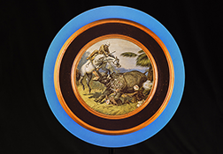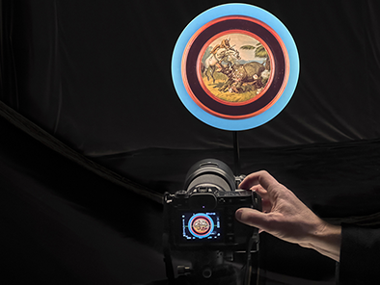
In a normal exhibition, these four levels are reduced to two: the viewer and the image. Hence there is a simplified representation of: “What is nature?”
Seen as abstracted, every image is a model of nature. It is not a real image “of nature” but rather a model of nature, an approach to “nature.”
In that sense, Sinje Dillenkofer’s works do not show “reality” but rather models of reality that are more or less provided by the machine. Her models are marked by different ideas, conceptions, and strategies.
In the work Natura Morta, a wall installation composed of two tapestries, the view from the front and the view from above interpenetrate in a paradoxical spatiality. Two photographs, taken in 1902 and 2002, respectively, are related to each other. In dem monochrome, historical image, Carlo von Erlanger and three men have brought together traces of nature, horns, and furs that will later be stored in archives. In the second color photograph by Sinje Dillenkofer, there is a front view of five trophies by Carlo von Erlanger lying horizontally in a role on the floor of the archive of the Naturhistorisches Museum in Mainz. In the exhibition, these trophies appear again as an image, arranged vertically and hanging on the wall. They seem real, three-dimensional, spatial. Then you notice that they are images and not real objects. Every image is a model and has its own frame of reference. Yet the wallpaper with the historical images forms a real frame around the second image-model, which is lying down, slightly set back, somewhat like a stage. At the same time, the historical image is framed externally by the architecture of the wall niche. On the one level of image and model, one sees fragments of bones and remnants of animals and on the other empty shells of taxidermic trophy heads enable one to guess which animal the bones might have been belonged to when they still performed a life function. I am dealing with a diversity of observations and models that represent precisely the visual quality that constitutes the human being’s relationship to nature. There is no direct relationship of the human being to nature. There are only models that the human being makes of nature. Even when I come up with an explanation of nature, it is already a model. The explanation of nature depends on the nature of the explanation. The choice of the model defines the model that the human being makes of nature.
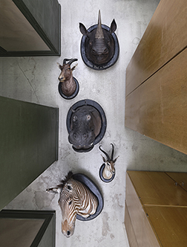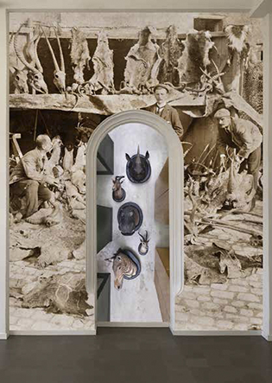

An animal would explain nature differently than a human being or so-called artificial intelligence would. If we regard the last of these positively, it will show us patterns that the human idea does not see. Systemically and metaphorically linked, this becomes evident in the three-part black-and-white work Metamorphosis 1, la Nature d’après Alexander von Humboldt.
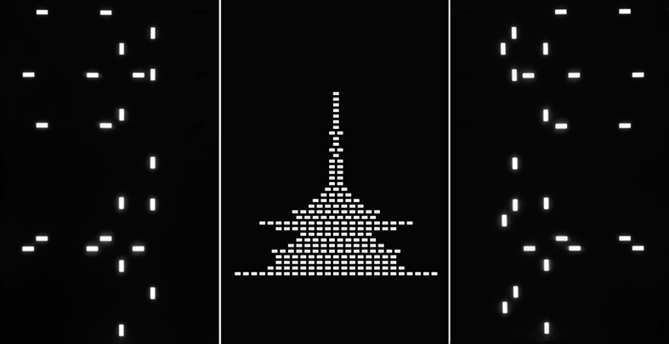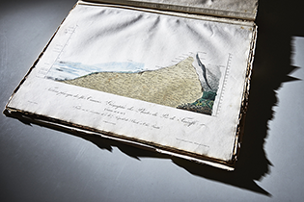

It refers to the print Géographie des Plantes du Pic de Ténériffe, 1817, after Alexander von Humboldt. All of the plants that Humboldt had studied on the Pico del Teide are entered here for the first time, with their names and the altitude in meters at which they were discovered on the volcano. This historical image is a kind of graphic “analogous” model of reality, which is in keeping with the technical possibilities of the time, such as printing, engraving, and coloring. The historical print corresponds to the semiotic type of an iconic rendering based on visual similarities. But it cannot show us any of the hidden patterns and operations by which this image functions. Only the use of another, new, numeric, geometric method makes it possible to show something that Humboldt’s historical image does not show.
Whereas the form in the central image of the three-part work still resembles that of a mountain, the elements see to the right and left of it remain enigmatic. They were turned into other patterns by certain technical procedures. Viewers can only decipher them when they know that white, rectangular areas in these two photographs are openings in the bottom of an empty, industrially produced drawer of a metal cabinet for graphic works. beyond analogies to abstract forms, it reveals to viewers connections to the subject matter and metaphorical observations as a third level of the model. The color black stands for the infinity of the universe, darkness, archive, and death. The color white stands for light, chlorophyll of the plants, and life. It is about questions of the meaning of plants for nature and archive from today’s perspective and about the ordering systems of archives as the fourth level of the model. Plants that once grew and were alive in nature according to their own laws are now found “killed” in the darkness of collection archives that are protected from light and are equipped for efficient storage, systematized according to DIN standards. Because the plants are photographed, they come “alive” for a moment as an image; they enter the archive and ordering system of art. What information is left behind in each case, gets lost, reforms our understanding of nature?

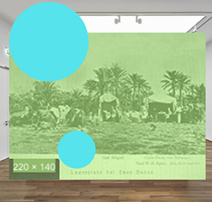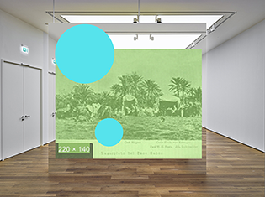
Exhibitions on the subject of the archive are normally presented as if visitors were experiencing an immediate, auratic closeness to the exhibited object. Here, by contrast, it is shown in a highly differentiated way that, no, we have no immediate access but instead have models of models of models before our eyes, and the nature of the model depends on the state and the experiences of the viewers. That is made clear by the work Target: A photograph shows an empty room in an exhibition with a partition wall papered with the photograph TARGET, which in turn shows the empty room in the exhibition with the photograph TARGET. In fact, however, in the photograph of an empty room we are not seeing a real wall and a real photograph but rather an image of an image with an image—an image in which a wooden floor is seen that as an image is in turn part of an image with the same wooden floor. One sees a chain of pictures or, more precisely, of models. I recognize that it is the floor in the exhibition space on which I as a visitor to the exhibition am in reality standing and that I am looking into the room from precisely the standpoint from which the photograph was taken. I see and experience the same room in a different time and how in the photograph not only the remote room but also the present room and the present time are reflected and inseparably combined. This space-time level of the model is reinforced by a green image from the Internet. With a resolution of just a few pixels, it looks like interference. The tents and palm trees of a camp can be made out. Thanks to the World Wide Web, the Africa expedition in 1901 that was once exclusively personal for Erlanger becomes accessible to all in a metaphorical sense.

This presentation of the artistic transfer of an archive by Sinje Dillenkofer makes it clear that nature and human being cannot be separated from each other and that a depiction of nature depends on a large number of methodical processes and on the apparatus. The apparatus is part of what is depicted. That which I depict is dependent on the state of the apparatus itself, and the apparatus is part of what it depicts. We observers in turn are part of the apparatus that we have created, and the apparatus is part of what it depicts: Nature is a system that I observe, not as an external observer but as an internal one. I am part of the system that I observe; I am part of the model that I have made of the world around me. That is to say, I am in the world around me, and the world around me is in me. With the phrase “world around me” I automatically have the feeling: That is my world—I am sitting here—and nature, the world around me, is there: the world that is around me. But that is not the case. I am also around the world around me. The world is around me, but as an observer I have constructed a method, an apparatus, which so that I am also around the world around me.
Nature is dependent on my perspective. Nature is what I make of nature, and when I have new methods, new tools, not just the brush, stylus, or camera, then I create a new nature. That means that “nature” is an infinite process. That means that what we view as nature today is how nature appears to us today with our current methods of depiction and research.
Because the methods of depiction are part of what I see, I can conclude from that: When I have new methods of depiction and techniques of presentation, the image I have of nature will also change. The image of nature is dependent on the methods and apparatuses available to me.

The three-part work Cosmos 2 consists of a view of Pico del Teide and two views of star movements. It is an image of nature supplemented by new parameters:

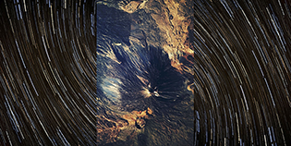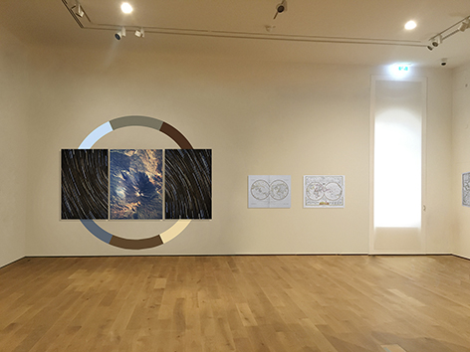

As an object presented on the wall in an exhibition, parameters and geometric patterns of nature that are hidden in the work are brought out artistically, abstracted, absolutized, and made visible: the forms of the circle and rectangle relate to the five Platonic solids, the basic geometric elements with which we observe nature. They recall the Cubist idea of reducing nature, in its hidden basic patterns that we do not see with our natural perception, to certain basic geometric volumes. The colors for the design of the wall painting of the circle surrounding the three-part work are “taken” from the three photographs. The circle extends the two-dimensional space of the photographs to the space, to the wall behind them. In the photograph of the installation, the exhibit and the wall paintings remain two-dimensional. Only the visitors in the real space experience the wall as a support and the three-dimensionality of the work as a whole.
The work being made here is an extreme relativization of nature, because the explanation of nature is already part of nature, because our “image” of nature is already part of nature.
The nature that I experience is already an explanation of nature, and the explanation in turn part of nature. They work each other up. So what is the model and what reality? I never really have nature before me, only models of nature and of reality, and the various models do not rule each other out. In the work Target, the wooden floor is real and part of the models or images. It cannot be said that the real floor and the photographed one contradict each other. Both are valid. Not, of course, in the same, comprehensive sense. I can walk on the real floor but not on the photographed one—but, conversely, I can say that a dog can pee on the real floor and on the floor depicted in the photograph. That is to say, when we distinguished between so-called reality and an image, in many cases reality has greater sensuality, functionality, and dimensionality. Some models are better suited, some less, and the functionality of the model is always dependently on my own interests and explanations. No model is wrong; rather, I can only observe that the relativity of the models is defined by my interest. You can see that every well in the photograph Moove from the Senckenberg Naturmuseum und Forschungsinstitut in Frankfurt am Main.

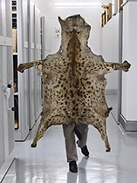
Here someone, the curator herself, is holding up a preserved hide of a hyena in front of her. One sees the four extremities of the animal. Of the person, one sees only two legs and her hands. Two different models of life and creature are brought together here that are, at this moment, the same even though their actual multifunctionality is different. The view of the hide from behind signals running away, while the position of the person’s feet indicates an approach that seems almost aggressive. She is carrying the hide in front of her much like a protective shield, an emblem, an instrument of power.

The way that Sinje Dillenkofer presents archives is multimodal, multidimensional, not simply relativizing but going beyond that to emancipate relative models as models of equal value. So every model relativizes in a certain way what it depicts, but we never know precisely what we are seeing depicted. This reality escapes us. We can only make models, really. Whether with the naked eye or with apparatuses. Models determine what nature is. We do not know what nature is. The nature of “nature” is inaccessible to us as an absolute. We have only models of nature and explanations—and explanations are models.
The explanations continue to change with the tools, because I can produce new theories and new models—and new theories and new models permit new tools.
Before we had a microscope, we did not know that microorganisms exist. We had models of nature without microorganisms. Then suddenly we had a tool, could see microorganisms swimming in a drop of water, and had a new image and model of nature and of the drop of water. The more the tools and observations evolve, the more highly differentiated models of nature I can make. A model of nature may no longer be valid, because we have found new models that are valid, but that does not mean that all the models of nature I once found are invalid.
Alexander von Humboldt (1769–1859) provided models and insights in his day that are still valid. They are symbiotic models, as is also true of the works of Sinje Dillenkofer. Today we have scientists like Lynn Margulis (1938–2011), who in her books describes the world as a symbiotic project and reveals two essential insights that are new: First, the absolute, mutual dependency of all living creatures, which used to be called cycle. Humboldt was the first to show how the water and cloud cycle functions, that what which exists under the earth, such as volcanoes, also exists above the earth. He already observed back then what has been confirmed today as crucial and new by scientists such as Margulis, as her second insight, namely, that living creatures do not just adapt to their environment but are also able to shape their environment so that it will support life. Humboldt was a pioneer in this as well. He already recognized that living creatures not only adapt to a changing environment but also have the ability to alter their environment to create more favorable living conditions for themselves. This can be demonstrated even with bacteria and other microorganisms. Humboldt wrote, under the title Kosmos (translated as Cosmos), his “sketch of a physical description of the universe,” which he published in four volumes from 1845 to 1858. Taking up that thread, the Austrian geologists Eduard Suess published his three-volume Das Antlitz der Erde, 1883–1909 (translated as The Face of the Earth). Since the nineteenth century, we have known thanks to earth system science how fragile and vulnerable our existence is, how much our lives depend on the state of the atmosphere, and specifically from a very thin layer, the so-called critical zone, of the earth’s crust.

The project of the universe is still unfinished, so to speak. Consequently, the potentials of our nature and the potentials of the human being as part of nature are not yet exhausted. What “exists” today depends on what I know exists today. When I expand the horizon of my knowledge, when I make new models, that which exists also expands. So reality is merely a result of what I know about reality. That is the model character. Sinje Dillenkofer’s works show that nature is a mutable, unfinished project. She succeeds in conveying that by realizing the archive in the exact way it happens in her works, namely, by taking the objects from the archive not as objects of nature but in their model character as the point of departure for her work.

